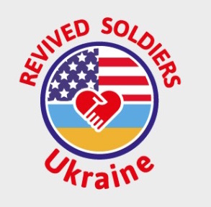 **Iryna Vashchuk Discipio**

**President, Business Development**

**134 Detmar Dr, Winter park FL 32789**

**+1(213)926-6627**

**Revival Soldiers UKRAINE Non for Profit Organization**

The purpose of the organization is to help Ukrainian wounded soldiers to receive a good quality medical care in US that the soldiers unable to obtain in Ukraine. The organization is going to cover the cost of travel, US Visa, medical care and rehabilitation for the wounded man. For the most cases we are negotiating with the doctors and their hospitals to accept wounded soldiers on pro bono basis to receive much needed medical help. We help soldiers to obtain foreign passport, get permission to leave the country for the period of medical care in US from Ministry of Defense in Ukraine and obtain the medical US Visa B2. Also, we work closely with the Ukrainian consuls in New York, Washington DC and San Francisco as well as Ukrainian Catholic and Orthodox Churches to help and assist soldiers with a room and board (if the patient does not need to be at the hospital). In addition, we getting involved the Ukrainian local community and Ukrainian churches to help with every day needs to the soldier.

Another goal of the organization is to unite all the Ukrainian communities all over US by helping wounded man. Get local Ukrainian non-profits to work closely with us on raising funds and spreading word on the wounded man needs in the region.

Looking for in US: We are looking to get involved Ukrainian-American and American doctors that can provide medical care for wounded soldiers with complicated wounds (deep burns, reconstructive surgeries, orthopedic upper and lower body, spine surgeries, abdominal organs wounds, complicated eyes wounds, etc). We are looking to establish close relations with the hospitals that can provide a charity work for wounded soldiers. Also, we are looking for hospitals to donate medication, medical supplies, equipment, emergency rooms beds, etc. to assist Ukrainian Army Hospitals all over Ukraine with much needed material. We also working on helping Ukrainian doctors to receive additional up to date medical experience by coming over to US and do an internship within the US hospitals.

In Ukraine: We will assist Ukrainian wounded soldiers with the medical needs. Will be helping soldiers to purchase much needed medicine, medical supplies, sponsor rehabilitation, travel to rehabilitation centers, etc. Will be helping wounded soldiers with disabilities receive much-needed place to live within Ukraine (accessible to disable).

Iryna Vashchuk Discipio